This month will be filled with many new and exciting activities. We will focus most of our month around the art of our imagination and becoming an author. Our class will start a weather chart this month during circle time and we will see if we have had more sunny days, rainy days or more snowy days. We will be getting outside more and more this month and we will use this opportunity to take nature walks to look for the first signs of spring!
St. Patrick’s Day is also in the month of March. MMPS will celebrate with “Green Day” on March 17th. We always get a visit from the pesky leprechaun. He has never been seen but always leaves a mess where ever he goes. Our Math Center will have different ingredients to make “Leprechaun Brew” to help us catch our little friend. Also, the Sensory Table will be filled with beads, gold coins and shamrocks for the children to play in. One of our many fun activities we have planned this month is to work together to create a leprechaun trap! If you have any cardboard boxes, stickers, tubes or tape to help us make a trap, feel free to donate to our class before Tuesday, March 15th.
In honor of the great Dr. Seuss’s birthday, we will create an author’s table in our Writing Center. The children will have blank books and supplies to create their own story. We are excited to see the creativity this will bring. We have also set up a listening center in the library for the children to listen to stories on CD’s. Our Dramatic Play Area has been transformed into a mechanic shop. We are learning how to fix, paint, wash and service vehicles. We have a variety of different tools, sponges and safety equipment to bring the job to life for our students this month. One week this month, we will be focusing on transportation during our art activity time. We will design our own race car then take them out to race. We will put our cars in paint and create tracks, and make edible traffic lights!
We are inviting parents to come in and read to the class. We have posted a blank reading calendar above the white board in the hallway for the month of March. If you can read to our class at 11:45am, please sign up by adding your name to the day you are available. The children love to be read to by someone special!
And if that’s not enough, we also are throwing in Sprit Week this month for the week of March 21st – 25th. Each day of the week will have a different theme and we invite the children to join in. More information will follow is a separate notice.
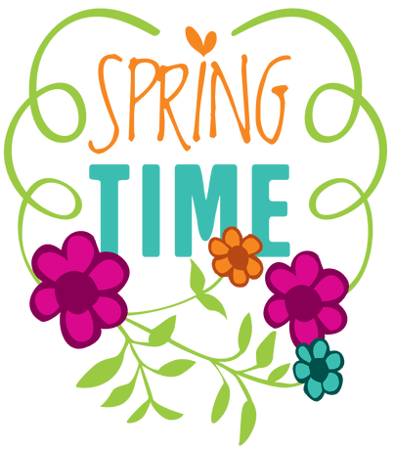
We have welcomed a few new families since January and we are so very proud of the way our class has easily adjusted to new faces and the willingness to help a friend with the expectations of our preschool routines.
As always, thank you for putting your trust in us as your child’s first educators.
Sincerely, Mrs. Hosmer

Upcoming Dates To Remember:
-Mar 17 -- Green Day/Happy St. Patrick’s Day
-Mar 21-25 -- School Spirit Week/More Information to Follow

