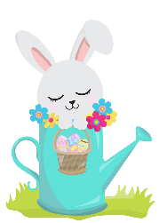
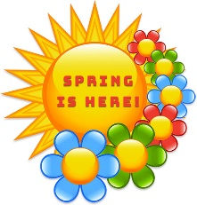
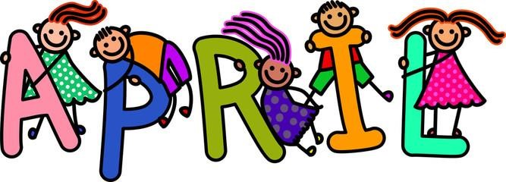
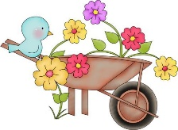
Hello April and welcome back Spring! We are looking forward to warm spring days to venture back outside on the playground to strengthen our gross motor skills. We do have playground rules that we enforce for the children’s safety. We encourage you to do the same if you stay and play after school is dismissed. Proper play gear is important too. Sneakers and play clothes that you don’t mind grass stains or dirt on is best. Part of a child’s play is falling and getting dirty and exploring with their whole body.
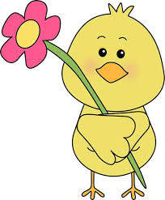
April is all about flowers and butterflies in our classroom and looking for signs of spring outdoors. We have been tracking our weather patterns for spring during our circle time. We will return from April vacation with caterpillars in our classroom and discussing all the different stages a caterpillar goes through to become a beautiful butterfly.
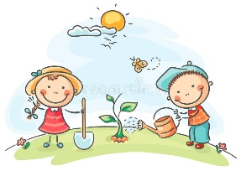
This month our centers have fun and exciting activities for the children to discover and learn about spring. Our Science Center has our own green house for us to fill with all different colored flowers and grass the children will plant and watch grow throughout the month. Our Sensory Table has turned into an egg hunting area. The children will have so much fun looking for eggs hidden in the colored crinkle paper. The Writing Center provides the children an opportunity to practice their pencil grip with our free art Boogie Boards, and the Math Center has little colored birds to sort in their nest.
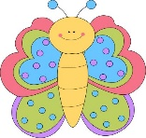
The Lapinski family from Gooseberry Farms generously donated flower seeds, soil and planters for our class to plant, water and watch grow. We will be working on identifying all the parts of a plant.
I will continue to leave a blank calendar outside our classroom door for special readers to sign up. Our children love having someone special come in and read to them. They have their best listening ears on and everyone is excited for a new book.
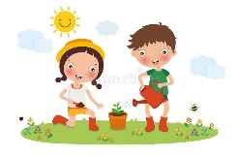
Happy Spring everyone!
Mrs. Hosmer
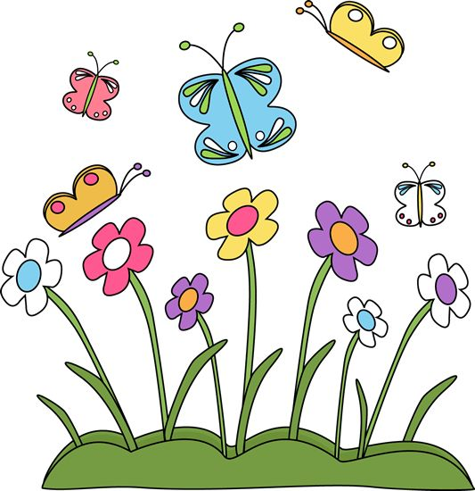

Upcoming Dates To Remember:
-April 15 -- No School, Good Friday
-April 18-22 -- No School, Spring Break

