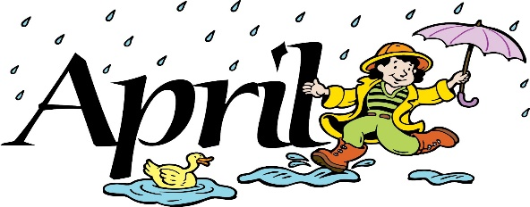

Director News 2022

**Frequently Asked Questions About Car Seat Laws in Massachusetts**

**Question:** **What is the Child Passenger Safety law in Massachusetts?**

**Answer:**All children riding in passenger motor vehicles must be in a federally-approved child passenger restraint that is properly fastened and secured until they are 8 years of age or over 57 inches tall. Children older than 8 years of age or taller than 57 inches must wear seat belts.

**Question: When can my child ride in the front seat?**

**Answer:** The back seat is the safest location for all children. It is recommended that once a child turns 13, they can ride in the front seat.

**Question:** **How can I determine if my child is ready to transition from a booster seat to a seat belt?**

**Answer:** When children outgrow their booster seats, they can use the adult seat belt **in the back seat** if the belt fits properly. If fitted properly, a child should be able to:

* Sit with their back and hips against the car seat back and sit without slouching.
* Bend their knees easily over the front edge of the seat and keep their feet flat on the floor.
* Safely wear the seat belt - Lap belt low and snug across the hips, shoulder belt across mid-chest and shoulder.
* Use the properly adjusted vehicle head restraint.
* Remain in this position for the entire ride.

*Preschool Registration*

Open enrollment for preschool slots for the Fall of 2022 school year are now open to the general public. If you have not secured your child’s space, please stop into the office for a registration form ASAP as we have limited enrollment.

**Covid-19 Update**

MMPS has lifted our mask mandate as of April 4th. We ask that you please continue to test your child prior to attending preschool each week. We will continue to send home free testing kits on a bi-weekly basis.

If you prefer your child continues to wear a mask while indoors, please let us know and we will gladly honor your request.

As always if your child is experiencing symptoms or needs medication to alleviate symptoms they should remain home until they are feeling better.