It’s March and leprechauns, shamrocks and all things St. Patrick’s Day are in the air! The children are very excited about what mischief those leprechauns will be up to at MMPS!

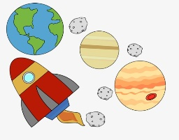
We will be doing several St. Patrick’s Day art projects this month, concentrating on using and strengthening the children’s fine motor skills with cutting, pasting, painting and drawing. We will also be encouraging the imagination and creativity of each of our master artists!

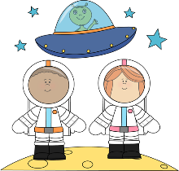
The theme in our classroom this month is “the solar system.” Our classroom is decorated with solar system posters and we have many books about space for the children to look at. There are comfy chairs, books and an outer space themed felt board in our Quiet Corner. We have several different magnets for the children to experiment with in our Science Center. There are astronaut costumes in our Dramatic Play Area and many space themed toys for the children to explore. Our Sensory Table is full of space rocks (black beans!), rockets, astronauts, stars, foam planets and marbles.

We will be talking about the solar system, constellations and space travel. We will be doing art projects based on space. We are working on the letters S, J, D, P and B this month and the children will continue to work on printing their names. The color this month is green and the shape is circle. Also, this month MMPS will be celebrate Spirit Week during the week of March 21st-25th. Each day of the week will have a different theme and we invite the children to join in. More information will follow in a separate notice.

Happy St. Patrick’s Day and Happy Spring!

Mrs. Protono and Mr. Cardillo

Upcoming Dates To Remember:
-Mar 17 -- Green Day/Happy St. Patrick’s Day
-Mar 21-25 -- School Spirit Week/More Information to Follow

