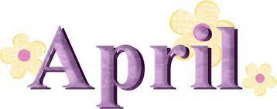

Happy Spring! Thank you for your contributions for our St. Patrick’s Day special snack last month and for your generous donations of disinfecting wipes!
This month we are learning about dinosaurs and fossils. We also have a race car area where there are cars and race tracks to experiment with. Which car goes faster? Which track sends the cars further, the longer track or the steeper one? The Dramatic Play Area has mechanic vests to wear and butterfly dresses with wings to celebrate spring.
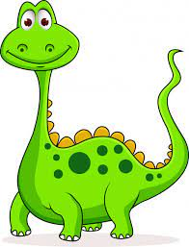
In our Science Center, we have an excavation site where the children can dig fossils and dinosaur bones out of the sand and then assemble a dinosaur with the bones. The Block Area has dinosaurs of all shapes and sizes to play with, complete with vegetation and log shaped building blocks.
In the Sensory Table, there is “dirt” to dig in, rocks, dinosaurs, fossils, adventure vehicles and brushes to move the earth around. There are magnetic letters on our magnet board, as well as plenty of dinosaurs. Our felt board displays a prehistoric scene that can be reconstructed to encourage imagination.
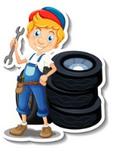
We continue to work on letter and number recognition, counting, simple math, how to write the letters in our names and how to grasp the pencil correctly. We will be cutting, painting, gluing and coloring with crayons, paint and markers to increase finger strength and small motor skills. We are talking about our emotions, recognizing what we are feeling and how to express them.
We will be playing, exploring and experimenting outside now that the snow and cold weather are behind us (hopefully!) so appropriate play clothing is greatly appreciated.
We wish you all a Happy Easter and a wonderful spring break!
Mrs. Protono and Mr. C.
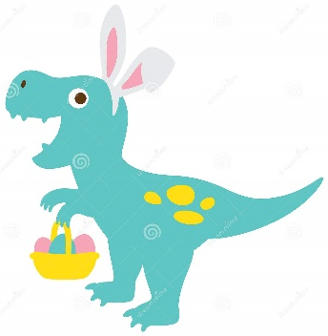
Upcoming Dates To Remember:
-April 15 -- No School, Good Friday
-April 18-22 -- No School, Spring Break

